Given the head of a linked list, reverse the nodes of the list k at a time, and return the modified list.
k is a positive integer and is less than or equal to the length of the linked list. If the number of nodes is not a multiple of k then left-out nodes, in the end, should remain as it is.
You may not alter the values in the list's nodes, only nodes themselves may be changed.

Example 1:
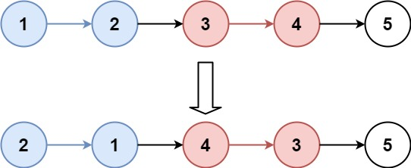

CODE
class Solution {
public ListNode reverseKGroup(ListNode head, int k) {
if (head == null || k == 1) return head;
ListNode dummy = new ListNode(0);
dummy.next = head;

ListNode prevGroupEnd = dummy;

while (true) {
ListNode kth = getKthNode(prevGroupEnd, k);
if (kth == null) break;

ListNode groupStart = prevGroupEnd.next;
ListNode nextGroupStart = kth.next;
ListNode prev = nextGroupStart;
ListNode curr = groupStart;

while (curr != nextGroupStart) {
ListNode next = curr.next;
curr.next = prev;
prev = curr;
curr = next;
}
prevGroupEnd.next = kth;
prevGroupEnd = groupStart;
}

return dummy.next;
}

// Helper to get the k-th node from current position
private ListNode getKthNode(ListNode curr, int k) {
while (curr != null && k > 0) {
curr = curr.next;
k--;
}
return curr;
}
}
:
